Course Outline
ChE 625 - Advanced Chemical Engineering Reactor Design
Spring 2019
MW 9:00-10:15, ESB 201

Instructor: Dr. Hanjing Tian, 435 ESB, htian@mix.wvu.edu
You are encouraged to take full advantage of these office hours, or to request alternative
arrangements as needed.
Objectives:
As the “exit” course of graduate-level chemical engineering program, students will:
- To prepare independent research and logic thinking capacity for your future career in domestic and international market;
- To develop a rigorous theoretical, conceptual and practical understanding of the principles on reactor design.
- To apply mathematical methodology into reactor design, thermodynamics, mass transfer, heat transfer etc. so as to to identify and to solve complicated, interconnected chemical engineering problems.

Key Outcomes:
- Naturally apply philosophy of mass/energy balance, and economic evaluation
- Fundamentally understand the basics of chemical kinetics and design equations for ideal reactors
- Logically Analyze catalytic kinetics in terms of adsorption, desorption, diffusion and surface reaction phenomena
- Quantitatively evaluate the performance of non-ideal reactors in terms of internal and external age distributions and non-ideal models
- Basic design of multi-phase reactors, such as fixed-bed and slurry-phase types

Textbook:
We will make extensive use on class-notes.

Primary textbook will be chosen by the student and his/her advisor based on your qualification and research interests from:

G. F. Froment and K. B. Bischoff, Chemical Reactor Analysis and Design, 3nd Edition, Wiley, New York (1990).
Or:
H. S. Fogler, Elements of Chemical Reaction Engineering, 5th Edition, Prentice-Hall, New Jersey (2006).

Other Reference book include:
J. B. Butt, Reaction Kinetics and Reactor Design, 2nd Edition, Marcel Dekker, New York (2000).
O. Levenspiel, Chemical Reaction Engineering, 3rd Edition, Wiley, New York (1999)

Other supplemental materials will be provided.

Office Hours: M: 1:00-2:00 (primary); W: 1:00-2:00 (secondary)

Makeup class time: Tuesday afternoon or Friday Morning

Prerequisites: Self-motivative learning, responsible to your advisor and your career

Steven C. Chapra and Raymond P. Canale “Numerical Methods for Engineers” ISBN-13: 978-0073397924, ISBN-10: 007339792X McGraw-Hill Education; 7 edition (January 24, 2014)
Undergraduate courses on thermodynamics, reactor design, physical chemistry or other comparative program.

Detailed mathematic derivative and data processing will not be provided in this class because this is not designed for mathematic review.
Dr. Tian is willing to provide mathematic instruction during office hour.
Necessary math knowledge will be distributed as handouts.

Evaluation: Based on the comments from Class-2018:
Quizzes (8-10 points),
Homework (30 percent),
A mid-term examination (30 percent),
Final examination (30 percent).
Collaboration will not be permitted in the quizzes and examinations.

Quizzes will be designed as closed-book, 10-minute questions.
Homework assignments will be relatively short-term problems, standard cover-page will be provided. The turnover is generally in 7-day. Late returns will not be accepted.
All HW must be submitted as paper-copy into DR. Tian’s mailbox before due date.
All homework questions are from multiple classical textbooks, to guarantee the correctness. See me if you have difficulty to solve.
Microsoft Excel is recommended if data programming is necessary, other programs are accepted. Data programming, figures, plots and tables can be submitted by email.

A mid-term will be a take-home comprehensive test.
Final examination will be in open-book in-class exam (2 hours).

Make-up tests will be allowed only in the case of a certified medical emergency, or an approved university activity for which advance permission must be sought from the instructor.

Numerical grades, not letter grades, will be issued for individual homework assignments, tests, the design project, and the final examination. Letter grades will be issued only for the overall performance in the course, following the weighting above. The following serve as “ceilings” of minimum performance to receive the corresponding grades: “A”= 90 percent, “B”= 80 percent, “C”= 70 percent, “D”= 60 percent. They are “ceilings” in that they may be adjusted downwards. That is to say, with a 89, you are guaranteed a B, but the actual final grade may be higher.
Attendance at class sessions is very strongly recommended. Those not in class for any reason are responsible for all material covered, homework assigned, etc., in that class.

Requests for re-evaluation of homework and midterm exam must be made within one week of their return. The reason for re-evaluation must be in writing. Request for modification of overall grading will only proceed by revising final exam, missing scores of HW, Quiz and midterm exam. No other re-evaluation will be made.

Progression: Topics tentatively include the following:
Review of undergraduate reaction equilibrium and reactor design
Catalytic reaction mechanisms: adsorption and desorption
Catalytic reaction mechanisms: adsorption and reaction
Catalytic reaction mechanisms: diffusion through bulk and pores
Catalytic reaction mechanisms: diffusion and reaction
Catalytic reaction mechanisms: diffusion, adsorption and reaction
Non-ideal (real) reactors, micro-mixing and macro-mixing
Non-ideal reactors, age distributions
Non-ideal reactors, models
Multi-phase reactors: fixed bed reactor
Multi-phase reactors: fluidized bed reactor

ADVERSE WEATHER COMMITMENT: In the event of inclement or threatening weather, you should use your own best judgment regarding travel to and from campus. Safety should be the main concern. If you cannot get to class because of adverse weather conditions, you should contact me as soon as possible. Similarly, if I am unable to reach our class location, I will notify you of any cancellation or change as soon as possible, using MIX, to prevent you from embarking on any unnecessary travel. If you cannot get to class because of bona fide weather conditions, I will make allowances relative to assignment submissions or quizzes on a case-bycase basis.

ATTENDANCE POLICY: Attendance at class sessions is very strongly recommended. Those not in class for any reason are responsible for all material covered homework assigned, etc., in that period.

SOCIAL-JUSTICE STATEMENT: “WVU is committed to social justice. I concur with that commitment and expect to maintain a positive learning environment based upon open communication, mutual respect, and nondiscrimination. WVU does not discriminate on the basis of race, sex, age, disability, veteran status, religion, sexual orientation, color or national origin. Any suggestions as to how to further such a positive and open environment in this class will be appreciated and given serious consideration. If you are a person with a disability and anticipate needing any type of accommodation in order to participate in this class, please advise me and make appropriate arrangements with Disability Services (3-6700)”

DAYS OF SPECIAL CONCERN: WVU recognizes the diversity of its students and the needs of those who wish to be absent from class to participate in Days of Special Concern, which are listed in the Schedule of Courses. Students should notify me by the end of the second week of classes or prior to the first Day of Special Concern, whichever is earlier, regarding Day of Special Concern observances that will affect their attendance. Further, students must abide by the attendance policy as stated on this course outline. Under these conditions, I will make reasonable accommodation for tests or other assignments that a student misses as a result of observing a Day of Special Concern.

ACADEMIC INTEGRITY AND DISHONESTY POLICY: West Virginia University expects that every member of its academic community shares the historic and traditional commitment to honesty, integrity, and the search for truth. Students should act to prevent opportunities for academic dishonesty to occur, and in such a manner to discourage any type of academic dishonesty. Please refer to the University's Academic Integrity and Dishonesty Policy for the definition of academic dishonesty: http://www.arc.wvu.edu/admissions/integrity.html.

Approximate Syllabus (this may change)
Key knowledge points will be the combination of undergraduate study and advanced knowledges
Pre-reading is recommended according this progress, even without teacher’s notice

Literature | content | Overlapped with Undergraduate?
1 | Introduction  Mass/energy balance | Yes
2 | Single reaction | yes
3 | Reaction network | yes
4 | Introduction to catalysis | yes
5 | Adsorption isotherm | Yes/no
6 | Langmuire-Hinsherwood mechanism | no
7 | Yong-Hugen table | No
8 | Introduction to Gas-solid diffusion | Yes
9 | Effective factor | no
10 | Gas-solid diffusion reaction | No/yes
11 | Introduction to Shrinking-core model | yes
12 | Shrinking-core model | No
13 | Shrinking-core model | No
 | Mid-term exam
14 | Ideal batch reactor | yes
15 | Ideal CSTR /PFR | yes
16 | CSTR/PFR combination | yes
17 | Micro-mixing | no
18 | Residence time distribution (I) | yes
19 | Residence time distribution (II) | yes
20 | Residence time distribution (III) | no
21 | Axial-diffusion model | No
22 | Tanks-in-series model | No
23 | Fixed bed reactor | yes
24 | Fixed bed reactor | no
25 | Introduction to Fluidized bed reactor | yes
26 | Fluidized bed reactor | no
 | Final Exam
+ Supplemental reading materials may be provided

Possible unavailability: Snow days
Project meeting in the last week of January
ACS Spring meeting 03/31-04/04/2019
One week in April 2019
Other emergency change
Detailed teaching plan will be noticed by email, usually one-week ahead by email
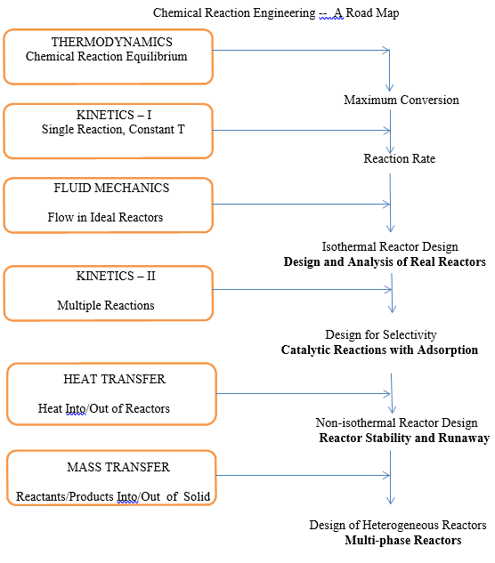

Modified from G.A. L’Homme, Chemical Engineering of Gas/Liquid/Solid Catalytic Reactions, G.A.L’Homme, ed., Editions Cebedec, Liege, Belgium (1979) p.1

